|  |  |  |  |
| --- | --- | --- | --- |
| Year 12 Worksheet 1 – Formative Assessment 3 | | | |
|  | | | |
| **Name:** | **Teacher:** | **Score /10** | |
| **Comment:** | | | **Time allowed:**  **15 minutes** |

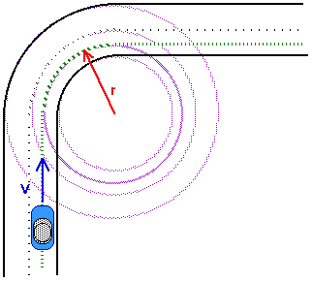

1. A car goes around the bend shown to the right.
   1. On the diagram, label the direction of its *change in velocity.* ***(2 Marks)***
   2. Support your answer using an appropriate vector method / proof. **(2 Marks)**

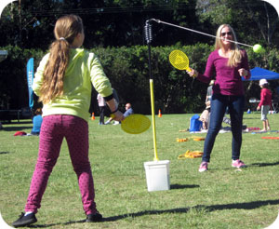

1. A mother and her daughter are playing a game of totem tennis, using a 60g tennis ball at the end of a 1.20 m string. The mother hits the ball with enough force so that it moves in a circle with a 1.00 m radius from the pole.
   1. What angle does the string form with the horizontal?

**(2 Marks)**

* 1. With what speed did the ball move around the circle?

**(4 Marks)**